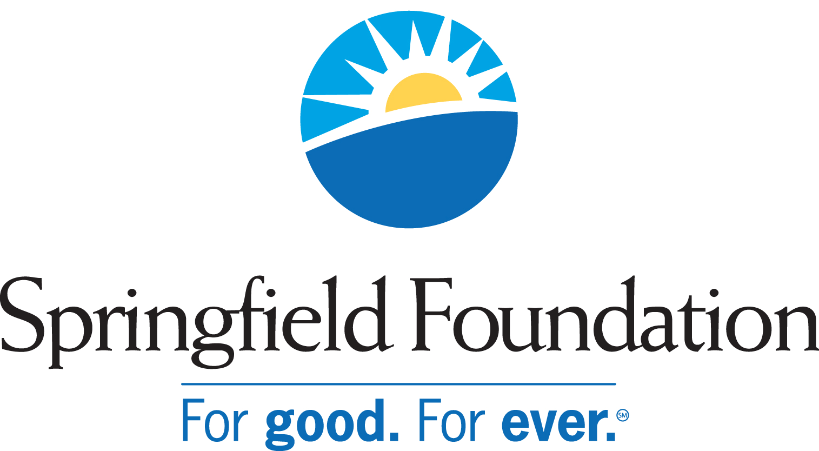

Agency Endowments Administered by the
Springfield Foundation

- Bethie’s Spray Ground
- B-W Greenway Community Land Trust
- Catholic Charities (3)
- Champaign Aviation Museum
- Champaign County Residential Service
- Clark County Historical Society/Heritage Center
- Clark County Mental Health Foundation
- Community Health Foundation
- Community Hospital Health Services Family of Funds (14)
- Covenant Presbyterian Church
- Dayton Children’s
- Friends Care Community Endowment
- First United Church of Christ
- Gary Geis Dance Company
- Glen Helen Association (2)
- Good Shepherd Evangelical Lutheran Church
- Grace Evangelical Lutheran Church
- Greenon Local School
- Grimes Flying Lab Foundation
- Greek Orthodox Church (Phil Chakeres Scholarship Fund)
- Hartman Rock Garden
- Hertzler House
- Highlands United Church of Christ(2)
- High Street United Methodist Church Cordes Fund
- Hollandia Botanical Gardens
- Kiwanis Foundation (4)
- Logan County MR/DD
- Mental Health Foundation
- Mental Health Services
- National Trails Parks and Recreation District
- Nehemiah Foundation
- New North Street A.M.E. Church (2)
- The Glenn A. Harper Endowment Fund for Preservation on the Ohio Historic National Road (OHNR)
- Opportunities Industrialization Center (2)
- Project Woman, Inc.
- Ridgewood School (3)
- Rotary Foundation (10)
- Springfield Arts Council (2)
- Springfield Family YMCA Fund
- Springfield Foundation
- Springfield Museum of Art
- Springfield Symphony Foundation (4)
- Springfield Symphony Orchestra
- TAC Enterprise Fund
- Tecumseh Council, Boy Scouts of America
- Tecumseh Education Foundation
- Tecumseh Land Trust
- Temple Sholom
- United Rehabilitation Services
- United Senior Services
- Urbana University
- Veterans Park Endowment
- United Way of Clark, Champaign and Madison Counties (5)
- WellSpring
- Westcott House Foundation (2)
- Yellow Springs Riding Centre Association
- Yellow Springs Senior Center

Summary:
- 100 Endowment Funds
- 58 Organizations

